BM (BrickMaster) Gameplay Sheet: version 2.0
LEGO B&B (Bricks&Battles) is an LMRPG (Local Multiplayer Role Playing Game). Similar to D&D, Lego B&B is played with at least three
people, one being the BM (BrickMaster) who controls and manages the fantasy world and NPCs (Non-Player Characters) the other players play in and meet. The goal of the game is to complete quests put forth by the BrickMaster and to evolve their RPG characters.

Players start off by filling out a Player Sheet for their characters (One per player). They start by filling out their name and their character's name. Then they pick an archetype and a class for their character. This determines what abilities their characters will have access to. The very small number of Archetypes consist of Human, Elf, Dwarf, Orc, Goblin, Creature, and Being. The most basic class is the Wanderer, who has only the basic stats. The following chart shows examples of levels and/or what abilities the different classes can give them:

 | Level 1 | Level 2 | Level 3 | Level 4 | Level 5 | Level 6 | Level 7 | Level 8
Mage | Poof! | You're a Frog! | Charm | Brew | Bless | Cast | Curse | FIREBALL!
Fighter | Mega-Punch | Super-Kick | Head Butt | Butthead | 2 on 1 | 3 on 1 | 4 on 1 | Finally Social
Knight | Honor | Courage | Loyalty | Trust | Discipline | Diplomacy | Truth | Shiny Armor
Ninja  Samurai? | White - Hide | Yellow - Jump | Orange - Dodge | Green - Stab | Blue - Flit | Purple - Throw | Red - Jab | Brown - Slice
Pirate | Bad Accent | Limb Loss | Gun-in-Boot | Map-in-Beard | Captain | Admiral | Survivor | Beef Jerky
Rogue  Time-  -Traveling  Robot? | Antisocial | Deception | Ominousness | Cleverness | Bring a Friend | Trust | Defender | Warrior
Archer | Boy | Hunter | Enlistment | Archleader | Archfiend | Archangel | Guardian | Trusted Protector
Bandit | Pickpocket | Robber | Burglar | Thief | Bandit | Robin Hood | Thief Lord | Bandit King
Peasant | Doofus | Seeds of Revolt | Rebel Leader | Commander | Sheriff | Governor | Friend | Understanding
Warrior | Loneliness | Anger | Enlightenment | Duty | Loyalty | Courage | Power | Conan
Druid | Meditation | Peace of Mind | Nirvana | Share the Love | Guru | Hippie | Wisdom | Keeper of the Peace
Royal | Ancestry | Heir | Leader | Ruler | Diplomat | Representative | Adviser | King/Queen/Prez.

Players can also make up a class with the BM's consent, or choose to be dual-classed (depending on their choice). Other classes, though not playable, are as follows:

 | Level 1 | Level 2 | Level 3 | Level 4 | Level 5 | Level 6 | Level 7 | Level 8
Orc | Grunt | Not Redshirt | Best Killer | Orc Leader | Orc Commander | Uruk-Hai | Uruk-Hai Elite | Uruk-Leader
Goblin | Petty Thief | Cutthroat | Pack Member | Top Gob | Goblin Leader | Goblin Elite | Goblin Ritualist | David Bowie
Troll | Baby | Toddler | Pre-Teen | Teenager | Mature/Warrior | Ogre | Enraged | Rraaarghh!
Demon | Demiangel | Innocent | Corrupted | Darkened | Strengthened | Evil | Demonic | Uber-Demon
Succubus | Slut | Uber-Slut | Mega-Whore | Succubus | Seductive | Skexy Evil | Super-Skexy | Evil Venus
Lord of Evil | Semidemon | Demon | Minor Devil | Devil | Lord High Devil | Devilking | Embodiment | Incarnate
Spirit | X-tra Small | Small | Medium | Large | X-tra Large | XXL | King Size | Supersize
Ghost | Spirit | Ghost | Spectre | Haunt | Dark Angel | Dangerous | Angel of Death | Grim Reaper
Undead | Mind Control | Kept Alive | Resurrected | Skellie | Zombie | Zombieking | Vampire Lord | Shade
Beast | Defensive | Aggressive | Rabid | Magic | Cursed | Mythical | Legendary | you be ded.
Sprite | Tinkerbell | Pixie | Brownie | Sprite | 7-Up | Mountain Dew | Pepsi-Cola | Root Beer
Fairy | Twerp | Midge | Fairy | Fairy Princess | Fairy Queen | Fairy Sorceress | Fairy Overlord | Archfairy
Monster | Squirrel | Wolverine | Bear | Sasquatch | Giant | Troll/Ogre | Balrog | Dragon
Cretin | Creature | Forest Being | Cavern Crawler | Lurker/Gollum | Goblinesque | Demonic | Master Cretin | Devil
Sea Creature | Clam | Fish | Ray/Gator | Turtle/Gamera | Shark/Croc | Octopus/Kraken | Serpent/Dragon | Leviathan

However, if their character dies, and they put up a good fight, providing they died gloriously, and providing that they attempted to stay alive (no suicide runs), and providing the enemy was of certain importance, and providing that the enemy was killed by another player who was close to the dead player, the dead player may choose to take on the character of another NPC, Providing the NPC is important to the overall arcing storyline and has somewhat constant interactions with the players. The dead player then takes a new Player Sheet card, keeping the old one for reference, and writes down the characteristics of that character. He/she may, if reasonably possible, give his inventory to a nearby player, and may instruct him/her to give his inventory to his/her new character. Note that the character to which he trusts his inventory to may not give some or all of it back, and that is perfectly legit. Whatever revenge actions taken are also completely legal. This new character may now be any class possible.

Players begin at level one. Their HP is their Health (stands for Hit Points). Every time they are wounded, they lose HP. There are also ways to regain HP, like by eating and resting. SP is a player's Spell Power. It is used like mana in other games: it is used to perform Magic, and is also used whenever a character's Abilities are tapped into. A player restores 5 SP each round in battle, and can set aside time to refill their SP if they find the time.
Experience Points (abbreviated Exp. Pts. or XP) are earned after a player completes a relatively pivotal action, be it after a battle, after a diplomatic meeting, or after a quest is completed. When a sufficient total of XP is reached, the player Levels Up, giving them better abilities, more strength, more HP and SP, etc. Each Level Up adds +10 to the character's max HP and SP. Statistics proceed as follows:

 | Level 1 | Level 2 | Level 3 | Level 4 | Level 5 | Level 6 | Level 7 | Level 8 | Level 9 | Level 10 | Level 11 | Lv. 12 | Lv. 13 | MAXIMUM
Exp. Pts. Required | 0 | 100  (+100) | 200  (+200) | 400  (+300) | 600  (+400) | 900  (+500) | 1200  (+600) | 1600  (+700) | 2000  (+800) | 2500  (+900) | 3000  (+1000) | 3600  (+1100) | 4200  (+1200) | N/A  (+3000)

Players' stats stop at their respective max. What follows is a list of abilities and/or items granted when they reach certain milestones:

Lv. 10 | Lv. 20 | Lv. 30 | Lv. 40 | Lv. 50 | Lv. 75 | Lv. 100 | Lv. 100 | Lv. 150 | Lv. 150 | Lv. 200 | Lv. 250
10th Lv.  Necklace: 100 £ | +50 Spell Power | Ability to buy a house | Ability to get married, Ability to Suggest NPCs | Ability to have kids (NPCs) | Ability to transfer to child | +100  Hit Pts. | Ability to have a third class | Can Die Twice | Gain Custom Weapon Ability | Gain Custom Class Ability | Gain Custom Ability

Purity is like how good/evil you are, how friendly/mean&scary you are. You begin with 85% Purity, because if you're playing an RPG you clearly aren't all that wholesome. Oh, and you mostly kill things in this game, which isn't that good anyway. A short table is good for classifying actions taken that raise/lower your purity:
Everything you buy, find, barter, steal, pick up, or otherwise own is in your Inventory. Whatever you physically own or are credited with goes into your inventory. The items that you can actually pick up and hold in the real world, the things that are tangible, go in a box called your Inventory Box. Things like money are just recorded down, like life points in Yu-Gi-Oh or credit cards. You don't actually take out a dollar bill from your pocket and hand it to the GM, though I'm sure that they would love for you to do that.

The tricky thing is, keeping track of things is a hassle, and can get disorganized. That is why the Inventory sheet sorts what you own into categories, making them easier to keep track of.

Hunger should not be confused with Sobriety Hunger is when you lose skill if you don't eat enough. Sobriety is how intoxicated you are. Your Hunger starts at 70, and your Sobriety starts at 8. You lose 60 Hunger points every day, in 10-20 point increments, at a constant rate. What follows are two short tables that outline the consequences of being Hungry and/or Drunk, and the BM has the right to make up other consequences if necessary:
Really Good: | Saving the Kingdom, ruling successfully | + 40
Pretty Good: | Aiding the helpless and oppressed, declining rewards | + 20
Just Good: | Completing a quest, doing lots of small tasks | + 10
Somewhat Good: | Giving something useless away, Returning a borrowed object | + 5
Tentatively Good: | Picking up a dropped object, placing something closer to its owner | + 1
Neutral: | Walking, eating, burping | +/- 0
Tentatively Bad: | Bumping into someone, Licking peoples noses | - 1
Somewhat Bad: | Knocking things away from people, hitting people, bothering people, overfeeding their pets | - 5
Just Plain Bad | K.O.ing innocent people, Bribing enemies | - 10
Pretty Bad: | Killing innocent people | - 20
Horribly Bad: | Psychologically torturing helpless people | - 40
Worse than the Devil Himself: | Selling one-hundred souls to Davy Jones so you don't die | Automatic 0 %

Almost Too Full: | 90-100 | + 3 Skill Mod
Hearty Helping | 89-80 | + 2 Skill Mod
Enough: | 79-70 | + 1 Skill Mod
Maybe a Snack: | 69-60 | +/-0 Skill Mod
Next Meal: | 59-50 | +/-0 Skill Mod
When's Lunch: | 49-40 | +/-0 Skill Mod
Please, Sir, I Want Some More: | 39-30 | - 1 Skill Mod
Could Use a Feast: | 29-20 | - 4 Skill Mod
Oh My Gawd!!!: | 19-10 | - 7 Skill Mod
Starved to Death: | 9-0 | - 10 Skill Mod

Chess World Champion: | 10 | + 2 Skill Mod
Bright: | 9 | + 1 Skill Mod
Hearty: | 8 | +/- 0 Skill Mod
Nonsensical: | 7 | - 1 Skill Mod
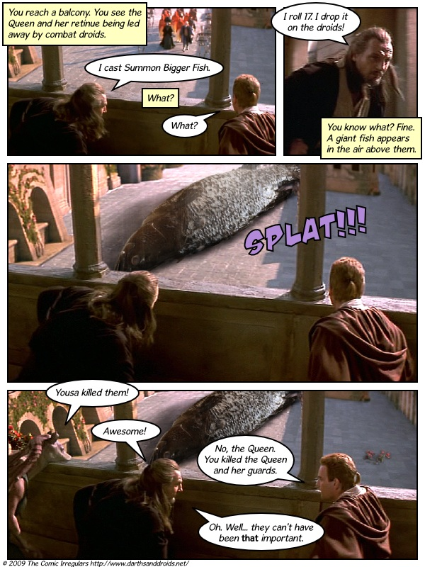  Hiccups:  Oh yeah. Summon Bigger Fish. Next best thing since Jesus. Kind of... | 6 | - 2 Skill Mod
Drunk: | 5 | - 3 Skill Mod
Blurry: | 4 | - 4 Skill Mod
Shaky: | 3 | - 5 Skill Mod
Indiscernible: | 2 | - 7 Skill Mod
Indistinguishable: | 1 | - 9 Skill Mod
Unconscious: | 0 | K.O., Not Awake
Pretty much self explanatory, Coolness is probably the most infrequently used...thing...in the game. You can get it by acting cool, doing cool things, possessing cool stuff, and wearing cool apparel and accessories, as well as owning/using pretty cool Weapons and Armor.
Coolness is pretty much an ego thing, and usually is just so that the PCs, when bored, will find entertainment in trying to ascend to and maintain status as the Coolest person in the party.
It can also be used in pivotal diplomatic encounters and as an intimidation factor. Do NOT, under any circumstances, underestimate the power of Coolness.
Skill is used for any action a player may attempt, be it running, jumping, knocking down a door or killing an enemy. Everyone's skill is a twenty-sided die (1d20). It is possible to add extra Skill in the form of more dice, or +X amount of Skill Pts. This is usually very expensive. Skill is used whenever an Action is attempted. More about this appears further into the rulebook.

Stat Pts. can buy you abilities. Abilities range from player to player, depending on their character's class. Here's an example on how and what to base different abilities' price on:

Personal | Some sort of Special Attack thing, or +1 to Skill for certain actions | 100-5000
Mental | Doubt, Suggestion, Confusion, Friendliness, Dissuasion | 100-500
Physical | Strength, Attraction, Defense, Attack | 100-500
Powerful Magic | Disintegration, Summoning, Resurrection, the Force, Teleportation, Cursing | 500-1000
Simpler Magic | Charming, Apparition, Incantation, Political Views Swinging, Miracle-Gro-ing | 100-500, 50 for Miracle-Gro, 2 for Political Stuff.
Psychological | Mind Read, Mind Control, Mind Explode | 400-1000
Other | Sickness, Huge Fireball without SP cost, Summon Bigger Fish | Sickness: 600.  Fireball: 2500.  Summon Bigger Fish: Priceless.

Battle Status:
Points are awarded for every fight you engage in and end. Keep track of your points; the more points, the higher your status.

Status | Pacifist | Initiate | Novice | Beginner | Intermediate | Mature | Advanced | Veteran | Master | Grandmaster | Champion | Warlord | Legendary
Points | 0 | 1 | 3 | 5 | 10 | 15 | 20 | 30 | 40 | 50 | 65 | 80 | 100
Level | 1 | 2 | 3 | 4 | 5 | 6 | 7 | 8 | 9 | 10 | 11 | 12 | 13

Battle Status (abbreviated BS) is used to determine the amount of Stat Pts. (Abbreviated StaPs) a player receives at each Level Up. At each Level Up, players gain StaPs equal to their BS level multiplied by 10.

If a player's Player Sheet overflows with Exp. Pts, Levels, Stat Pts., Abilities, and/or other things, the player may choose to write down his overflowing attributes on a separate sheet of paper, note card, or extra Player Sheet. This page/paper should be kept with their Player Sheet and possibly stapled to the Player Sheet itself.

You can draw a more detailed drawing of your character on a separate sheet, if you want. It's only for show, though.

The other official documents besides this one are: Player Sheets, Inventory and Bank pages, and a Character types page. The other documents are lists of the different kinds of LEGO weapons, armor, and items that I own, and I have compiled a long, detailed chart of their costs, effects, and other stuff. Use is as reference information. Unfortunately, I did not take pictures of these, because they would take up way too much space of the chart. However, I was able to find the part number of each piece, so if you look them up on www.peeron.com, you should be able to find a picture of the pieces used.

Playing The Game

The object of the game is to have adventures and complete quests in an ongoing fantasy-world game. But the REAL object of the game is to have fun. And win, but mostly have fun. This game is complex, and reading the rules may seem to be a hassle, but it is well worth it. A good example, though lengthy, of how this kind of game works, can be seen in the webcomics, "Darths and Droids," or ''DM of the Rings.'' Oh, and I recommend pasting the rules and items lists on a tri-fold board or something to keep them handy and organized.

To accomplish this, players must create characters and move around in and interact with a fantasy world the BM puts together for them. This can be played with imagination, or can be staged out in a miniature battle and adventure map/arena with figurines and buildings. The latter is usually more fun, but more difficult, because it involves (sometimes) the use of grid squares and the need to actually construct the world in one way or another. and if players go to the edge of the world, and want to go further, you need to think up and build an addition for it. So usually, building small enclosed areas that can be put next to each other and pretending to teleport to one room from another is usually how it works. It is still usually more fun.

This version deals with playing in a real-life constructed environment, and rules will need to be changed to allow for more, "imaginative" play (using your minds instead of little toys).

To begin, place your miniature figurines (Ha ha. Mini-figs.) where they will start. You can give them a rough plot outline and let them choose if they want to follow it or not. Keep them entertained by throwing less enemies at them, and more, semi-important NPCs and let them "choose" their relationship. And subtle story arcs and running gags keep them laughing, which is usually good. That means they are having fun and like the game, rather than wanting to tie you up and burn you, using the rulebook as kindling.

Also a reason to keep the rulebook as short as possible. Less kindling, less burn-scarring. Oh, and less reason to kill you anyway.

Back on track. Tell them where they are, and give them some sort of incentive to move the plot forward. then sit back and enjoy the fireworks. They will ask you what can they do, and reply "almost anything, within character.". They will love you for it. Let them explore at their own free will. And feel free to try to influence their decisions. They have the right to ignore you. At the beginning, they have anywhere between 0 and 200 £. Pound(s), because that is just so much cooler.

The game is played actively, and is not turn based. Certain challenges may be turn based. Battles are conducted in a blow-for-blow setting, and you can't attack a bazillion times in a row while the enemy sits there. Characters and enemies exchange blows back an forth with attacks and counter attacks, in a way similar to turn-based, but not quite. Rules are very lenient, and anything can happen, as long as it is not too far-fetched. Far-fetching multiple times, especially when joking around (without getting anything done) is not acceptable. Movement is also pretty loose. You can opt to run, walk, crawl, and even hop on one foot whenever you feel like it. Movement squares are only used in certain settings, like enormous dungeons and vast battle plains.

Most dice rolling takes place with d20's or d10's. Smaller actions, like kicking down a door, use d10s. Different power-ups and small effect rolls use d6es and d4s.

The rest of the game is governed by chance, statistics, and pure imagination. The GM mostly rules though. Common sense is usually better valued than pure hilarity, but a little bit of randomness and subtle running gags in the story line should suffice to keeping it interesting.

Enemies:
Enemies come in many shapes and sizes. Once you kill and enemy, you get Experience Pts. To determine how many Exp. Pts. you get, you need to calculate the Strength of the enemy. Different enemies get different powers, stats, and Exp. Pt. Levels. What follows are...guidelines, if you will:

 | Exp. Rating (Per Unit) | HP | SP | Notes:
Orc/Goblin | (Lv. #)/2 * d10 | Lv. * 10 | Lv. * 3 | Travel in packs. Shamans get double SP
Troll/Beast/Monster | (Lv. #)d20 or (Lv. #)d20*2 | Lv. * 30 | Lv. * 5 | Some fear fire. Others are stupid.
Demon | (Lv. #)d12*2 | Lv. * 25 | Lv. * 12 | Some vulnerable to fire, others love fire.
Sprite | (Lv. #)d6 | Lv. * 4 | Lv. * 15 | Usually quite small, can be drowned.
Spirit/Ghost/Undead | (Lv. #)d6 -3 | Lv. * 4, limbs may be severed. | Lv. * 1 | Head shot is instant kill, and you get double Exp. Pts.
Human - Grunt | (Lv. #)d10 | 60 + Lv. * 5 | Lv. * 5 | Mostly found in groups
Human - Difficult | (Lv. #)d12 | 80 + Lv. * 7 | Lv. * 10 | Groupings of about 2-4
Human - Boss | (Lv. #)d20 -5 | 100 + Lv. * 10 | Lv. * 15-20 | Often solo

Items:
Items are things you can purchase, sell, or pick up/steal along your travels. They can be utilized at almost anytime, except as an extra booster after you already rolled dice. Exceptions may apply.

Potions are Items that your character must drink. If they are Full, they cannot take a potion. HP and SP potions refill your character's current HP and SP gauges. They last until those points are spent or whacked out. Purity, Strength and Defense, and Skill Potions temporarily increase your character's gauges until a certain number of ''turns'' have passed, indicated by the number of dice rolled. Poison Potions are used to poison someone's drink, or to commit suicide. Only one poison can be used in someone's drink at a time. Poison is also highly dishonorable, and is often frowned upon. If you were to have been found out, your Purity (among those who know you) would drop 150% as much as the number of dice used in the poisoning (round up). And if you were to have failed as well, your target may feel the need to take revenge upon his assassin.

Charms are very similar to Potions. Charms can only be cast by Magic users. SP Charms reduce the cost of Spells. Purity, Strength and Defense, and Skill Charms work similar to their Potion Counterpart. Poison Charms can protect the user against any assassination attempts at formal feasts or populous bars when they sit down next to a shady fellow. Charms must be Learned from a teacher, which takes time, or bought with XP.
I'm a kill
you with
this here
drumstick.
Yeaah!

Crystals can be kept single, merged with tools or Weapons, or worn as an Accessory. You are allotted a maximum of 15 Accessories. They can be sold, but only at certain places or times, and can only be bought if you sold it to a certain person. In that case, they are basically bought back, though probably at a higher price that what you sold it for.
They can be found or even stolen.

Food is used to keep yourself fed. No duh. I mean, I guess you could try to use it as a Weapon, but it would suck. Really bad.

Armor/Weapons:
Weapons and Armor are very important. They are used to attack and as defensive pieces of equipment. Outside of basic attacks, certain Weapons have specific attacks, and certain pieces of armor can defend better against these attacks. These attacks sometimes require more skill, more strength, and sometimes more SP.

There are 6 different kinds of Weapon attacks (besides basic): Pierce, Crush, Slash, Magic, Burn, and Thrust. Pierce and/or Thrust attacks are used by daggers, some swords, spears, and possibly arrows. Thrust attacks can also be used by lances, and some shields, as in the event of a mob, police officers use big shields to push back the crowd. Crush attacks are used by maces, clubs, flails, and other blunt Weapons. Crush attacks also can sometimes be used by axes. Slash attacks are used by swords, some daggers, axes, and fingernails. Sharpened boomerangs and pointy shields can sometimes make slash attacks, but usually it's stretching the rules. Magic attacks are any general magical attack. Armor can either protect against magic attacks, or it can protect against some but not all magical attacks. A flame resistant cloak could protect against a fireball, but not against a magical tidal wave. Burn attacks are used by torches, primitive flamethrowers, flaming arrows, and some magic. Multiple attack types can be combined in an attack, such as a magical flaming arrow, which may combine Pierce, Magic, and Burn.
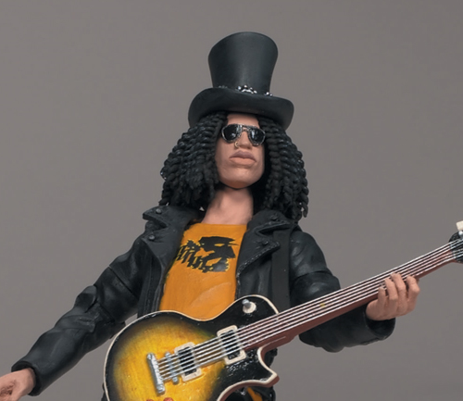
Ooh! Ooh!
I know
this one!
Armor bonuses are rolled after the attacker succeeds in an attack and successfully deals damage. First, any Parries
will deflect some of the damage. Then roll the dice for the amount of damage your armor absorbs. Subtract the amount on the
dice from the attack damage. Armor will not help against poison. If the poison is from a poison-laden Weapon, the armor will
protect against physical damage, but if the excess damage exceeds 5 points, you will be poisoned..

Certain creatures are vulnerable and/or invulnerable to certain attacks. Most Zombies will not die if Pierced or
Thrusted, except in the head. Certain Shades are vulnerable to Fire. Almost all Demons fear light. And George Bush
succumbs easily to bad pronunciation (“Thar be nukyuler weapons of mass destruktshumagayshun in them hills!”)
DM: Slash attacks! What do you do?

a. Panic
b. Scream
c. Run
d. Commit Suicide
e. Dance
|
|
|
|
|
|
|
____________________|

Burn attacks are special. Besides doing the initial damage of whatever the attack was, you roll 1d10. If the result is 3 or higher, the flame catches, and mark and record Burn Markers for each point of Burn Damage taken. Each round, roll 1d4 for each burn marker on the object, and the target takes that much more Burn Damage. If the target is left unattended to, roll 1d6 and add that many more Burn Markers. At the end of each round, roll 1d4. If the result is 1, all fires go out. If the result is 2, roll 1d10 and subtract that many Burn Markers. Any other case results in nothing happening. Boy, is that a lot.

Besides regular melee weapons, I have to cover the huge, abstract region of Magic. Hoo, boy. When Magical actions are used, after meeting the Action Rating (talked about later), you must pay the appropriate amount of SP to use the attack. Because it is difficult to come up with a system for determining how much SP is used in, say, a medium-sized fireball, and even more challenging to gauge the cost of a lightning strike, the BM should come up with an appropriate SP rating, one that enables multiple usages without refilling the player's SP constantly. Remember: as this rulebook consists of mere guidelines, rules may be changed it it better suits play.

Gameplay:
The classic
game starter is
usually a pub.
Turns are all quite loose, so I'll start from the beginning.

After purchasing your tools, equipment, and weaponry, and filling out your character sheet, the BM should give you all options of where to start the game. Perhaps outside a castle, in a pub, on the farm, inside a secret tomb filled with traps and treasure, you get the point. Some games require a specific starting point, others allow you all to begin separately. If you begin together, may I suggest a great, possibly cliché opening: a meeting of representatives from different kingdoms discussing how to combat the growing evil in the land of _____________ (fill in the blank).

If you begin separately, you can all begin somewhere respective to your Character's Type, and the BM will have to work with you individually in a way that will almost become turn based (AACK!). However, this is perfectly fine if you all join together eventually in some sort of meeting, be it all at once, or one by one. There can be one main character in the party, or you all can have separate but equal roles. Like the Fellowship of the Ring. Sorta.

AFTER everything is SET UP, play begins. Walk around and talk to people, ask the BM where everything is, and take it from there.

When you state that you are going to take an action, always start with “I....” For instance, if you want to order a beer, you say, “I get the bartender's attention”. If you want to run after an enemy's horse, say, “I pursue the dark rider.” If you want to go out with the princess, you say, “I seduce the lovely lady.” Unfortunately, on that last one, the BM will simply laugh and ask to help whoever is next who would like to do something reasonable.

If an action you take requires no hard work, such as crossing the street, the BM should restate your action and describe any reaction the environment has. In the crossing the street example, it should play out something like this:

YOU: “I cross the street.”
BM: “You cross the street, and see more rows of market stalls. The stranger you saw earlier looks over their shoulder, notices your pursuit, and darts behind one of the vendor's booth.”
YOU: “I pursue them further.”
BM: “You run up to the vendor's booth and look behind. You see the stranger's cloak disappear behind the
door frame.”
YOU: “I enter the...door frame? Door frame to what?”
BM: “Oh, the, uh, hut behind the booth. Someone notices you.”
YOU: “Who?”
BM: “You don't know who he is.”
YOU: “But can I see him?”
BM: “Yes. If you examine him, he does not appear threatening...or particularly burdened with valuable objects”
YOU: “Okay, so if there's no point in shooting and looting him, I enter the hut.”
BM: “Upon entering, you discover no one is in there. The only opening it the door you came in through. The guy who noticed
you either thinks you live there, or has ignored you by now and moved on.”
YOU: “So what was the point of the guy? Anyway...I search the room.”

This would continue to play out in a similar fashion.

NPCs, or Non-Player-Characters, are any other being you encounter on your adventures. NPCs are all run by the BM. All enemies are NPCs that you mostly would kill, and don't have a whole lot of back story to them. Other NPCs include peasants, guards, companions who are not represented by people at the table you are sitting with, and basically anyone else. Some NPCs could become allies if you treat them right or meet them under the right conditions. For instance, that stranger could become a valuable Rogue/Thief ally. They could join your party and help you on your quests. If you die, you might even be able to take over that character. Or you could kill them and loot their body. Your choice.

Back to actions.

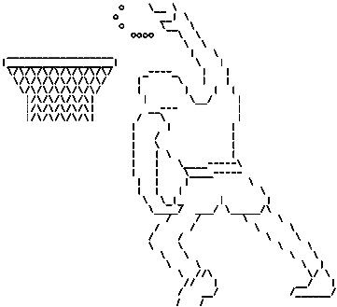
If an action (remember the “I” thing?) requires the roll of dice or a quick stat check, the BM should inform you so. For instance, if you try to jump over an abyss, the BM might say something like,

“Make an agility roll,”
Or,
“Would you like to use an Anti-Grav potion?”
Or,
I can haz
Air Jordanz!!!
“Psh, you have got to be kidding. You can't do that.”
“I use MagicFlyHangTimeLeBronJames.”
“Cheater.”
“It's not cheating! You're the one who let me be the B-ball-playing 9-foot-tall magical African Elf.”
“Don't remind me.”

Whenever you roll dice to perform an action, you are trying to meet that action's Action Rating (abbreviated AR). The outcome of an action that requires and AR is determined be the player's Skill. Whenever an Action is attempted, the Player rolls their Skill die (or dice). A players class may grant them reduced ARs for certain Actions: for instance, a Scottish Berserker, who is built for heavy warfare, would be able to wield battleaxes, steer ships, play bagpipes, and reluctantly shave beards far more easily than, say, an impoverished English farrier. Increased ARs could also happen, in cases of weakness or ineptness in your character's abilities. A water elemental would have increased difficulty in operating a fireball-hurler. Some weapons may even be forbidden from use in certain cases, i.e., a two-handed sword cannot be operated by a one-armed skeletal warrior.

The most common action requiring a Skill roll is jumping. To calculate the AR, multiply the number of ''feet'' (centimeters) between the figure jumping and the point of landing by 2, or if using LEGO-brick-built creations, count the number of studs/bricks high between the two places. Other ARs should be reasonably improvised whenever needed at the discretion of the BM.
Battles & Rolling:
Battles are simple once you get the hang of it. In order to explain, we'll use a mock battle to demonstrate.

“You are attacked by...two orcs on the forest road to _____________ (fill in the blank again)”. Now is where you get creative. You might just say, “I slash them with my sword” a couple times, roll some dice, and be done with it. OR you could liven it up a bit.

The cooler you kill it, then the more Exp. Pts. you get, the more interesting the story gets, and the more the BM takes a liking to you, because you play like a gamer. So instead of whacking them with a club, you could do something like;

Hide behind trees insulting them, making them think they're insulting each other, and eventually having them kill each other.
Stab one in the head and use it's body as a meat shield.
Throw your shield on the ground and ride it like a skate board, stabbing one and then flinging the shield through their neck.
Engaging in an arm-wrestling competition.
Bribe them, then stab them when their backs are turned and take back your money while raiding their corpses.
Trick them into getting eaten by a monster/falling into a hole/selling them their own armor/walking into a pair of nooses, and hoisting them up.
Beating them in a game of Tic-Tac-Toe.
Asking them riddles. Hard ones. Impossible ones. Ones that make their brains hurt.
Give them a Chinese finger trap, and then say that your magic is the only thing that can save them.

Because keep in mind, most battles can be brightened by a little quick thinking and a whole lot of sarcasm.

If, however, you want to do it the easy way, then follow these steps:

    - State your target (if applicable)
    - Explain your planned action(s)
    - Add Enhancements and Roll (expanded upon later)
    - Calculate damage
    - Check yourself
    - Rotate priority to the enemy.

Rolling is very important. It douses flames exceptionally well determines the outcome of any action. In battles, you add any enhancements, roll for your Weapon, and subtract Armor and other resistances. Subtract the amount, which is the damage taken, from the Target's HP. If you specifically target a certain unit of Armor that the target is wearing, and want to disable it, subtract only the Armor's resistance from the Weapon's damage. If the remainder is greater than the Armor's SR (Substance Rating), then the Armor is broken and fails to operate anymore until it is taken to a blacksmith or forger and repaired. Note this in the Inventory.

If your weapon is swordlike, or swingable, you may try to Parry. To Parry, you must roll to meet your weapon's MP +1. If you succeed, roll your weapon's damage, but without using any Enhancements (no +X's), and with one less die, and at a maximum of three dice.

The procedure for rolling, which is the most complicated step, is explained below. The acronym C.U.R.S.E. is made up of the first letters that make up the titles of the substeps.

    - CALCULATE: Calculate Enhancements (add/subtract any multipliers or extra effects)
    - USE: Roll to match or exceed the Weapon's Manipulation (MP) rating – This accounts for using the weapon AND hitting the target
    - ROLL: Attacker rolls for damage, then target rolls for Armor (if any)
    - SUBTRACT: Subtract Armor from Weapon Damage, then subtract result from target enemy
    - END / EFFECT: Determine outcome. Any extra abilities or side effects are applied here, unless stated otherwise

An alternate acronym is C.U.R.S.O.R.; if you replace the title of step 5 with OUTCOME, and add one more step; ROTATE: Rotate priority.

The MP rating is a subcategory of Action Ratings. It is, like all other actions, determined by rolling a player's skill.

Now for the Players' favorite part. When you kill an Enemy and you are not in any immediate peril, you may loot the dead for all that you can find of worth and carry. Standard Inventories hold up to 25 Weapons (each kind of ammo is one Weapon), 25 Armors, and 50 Potions. Bags, Sacks, Cases, Chests, and Pockets all can increase your capacity. You can also join a bank where you can deposit your Weapons and other paraphernalia at a bank and withdraw them, as you would money, from any other bank anywhere else. The cost of opening an account is anywhere between 10 and 50 £. There is no cost to deposit small items. Medium items cost 1 £, and Large items cost 2 £. Really big items must be carried via vehicle, or by multiple people, and cost between 3-10 £ to store. In this world, you can rob banks, but you cannot raid other players' accounts. If you are caught, you can still make withdrawals, but cannot make any more deposits. And remember this: MONEY DOES NOT NEED TO BE DEPOSITED.

Of Criticals:
A Critical Success, sometimes just called a Critical, is when a die result is the maximum for that die (i.e., a 10 on a d10, a 20 on a d20, etc...). If a maximum result is rolled, the die can be rolled again, further adding the additional points to whatever the die was being rolled for. For example, if a player rolls 2d10 and gets a 10 and a 4, the 10 die would be rolled again. If it came up a 7, the final result would be 4 + 10 + 7, or 23. rolled again is an addition factor, and should not be confused with a reroll. A reroll is when a die's past result is discarded, and the new result is used in its stead.

A Critical Failure (frequently referred to as an Epic Fail) is when a 1 is rolled on a die. If a one is rolled on all dice currently being rolled, then the outcome is an Epic Fail. A 1d6 coming up 1, or 3d10 coming up all ones are Epic Fails. If not all of the dice in a dice roll are ones, the roll is not deemed an Epic Fail. When Epic Fails occur, appropriate consequences should be assigned, and extravagant results are often enthusiastically supported.

Semi-Final Overview:
Here is a semifinal outline:

- Characters:
- Classes determine what kind of creature you are, which affects your ability options
- Abilities are special...things that your character can use whenever able and applicable
- Lots of actions and events can give your character Experience Points (abbr. Exp. Pts., Exp., or just XP.)
- Experience points increase your character's level, enabling them to use stronger items, powers, and other stuff
- HP is your character's health, and SP is your character's Spell Power
- A character's Skill is used to determine the outcome of almost all attempted actions (base 1d20, plus any add-ons)
- Roll to see if you meet or surpass the Action Rating (AR)
- Purity, Hunger and Sobriety have to do with wholesomeness, hunger, and drunkenness, respectively
- They affect your character's efficiency to complete actions and their interactions with other PCs and NPCs
- Coolness is cool
- BS makes Stat. Pts. (StaPs), which are used to buy character abilities
2. Inventory
- Anything picked up can go in your inventory
- Items are used for their corresponding effects
- Weapons are used to deal damage to enemies; Armor is used to absorb damage from enemies
- Overflow items may be placed in a bank
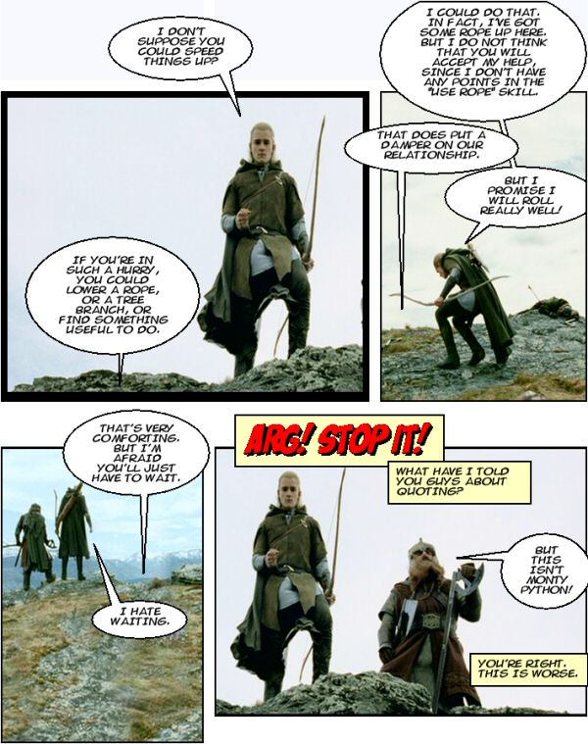
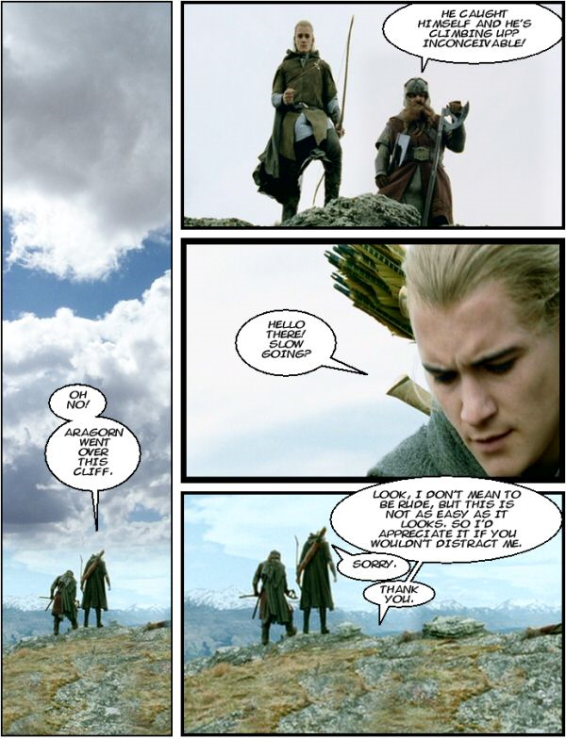
3. Gameplay
- When any actions are taken, proper dictation is mandatory. Remember the ''I'' rule
- Rolling:
  - Actions are either easy enough to require no die roll, or may involve the rolling of dice (uses Skill) and/or a quick stat check
  - Criticals:
    - Critical Success (Critical) = Maximum rolled on any one die. That die amount is remembered/recorded, and the die can be rolled again for an even higher total
    - Critical Failure (Epic Fail) = All dice come up minimum (usu. all ones). The action attempted automatically fails, and appropriate consequences are applied
4. Battles
- Battle flow:
  - State target
  - Explain your planned action(s)
  - Add Enhancements and Roll:
    - C.U.R.S.E. or C.U.R.S.O.R
      - Calculate Enhancements (determine effect of multipliers/extra effects)
      - Roll for ≥ Weapon's Manipulation (MP) rating (If failed at MP, consequences are determined, and battle ends there.)
      - Roll for Damage and Armor (if any)
      - [Target's HP – (Attacking Dmg – Target's Armor)] ¡Not: [ (Target's HP + Target's Armor) – Attacking Dmg ]!
      - Determine outcome. Extra abilities/side effects activate here, unless stated otherwise
      - Rotate priority
- MP = ManiPulation rating
- MP is a subtype of AR
- Loot when all are dead
- Don't forget about weaknesses/resistances
5. Other
- Be creative, unexpected, and humorous/entertaining

Abbreviation Key:

AR = Action Rating
BM = BrickMaster
BS = Battle Status
Dmg. = Damage
Exp. Pts. = Experience Points
HP = Health (Hit Points)
Lv. = Level
MP = ManiPulation rating
NPC = Non-Player Character
PC = Player Character
RPG = RolePlaying Game
SP = Spell Power
Stat. Pts. = Statistic Points
StaPs = Statistic Points
XP = Experience Points

Roleplaying:
The first 2 letters in the initialism RPG stand for Roleplaying. Roleplaying is when you act as if you really are the character, and contribute something to the story, be it dialogue, actions, or something else. Any thing that the players do is either in character, or not in character. If they do something well in character, it is considered a commendable action that deserves points. Most players should know this, but if they don't, you could make it interesting by not telling them, and surprising them with points whenever they actually play the game. You could also grant points if they successfully quote some famous movie line or something, which you don't have to tell them about either. However, if it bugs the heck out of you, then you can always deduct points...
Summary:
Alright, here's a catch up:

- Pick a Character
- Remember Level-upping, Exp. Pts. (XP), HP, SP, BS, Stat. Pts., and all that jazz
- Keep track of all effects to your character (similar to above statement)
- Don't forget about Items – NEVER misplace your inventory. It can get you out of a whole lot of trouble. Chekov's Gun comes in real handy.
- Fight by using To-Hit, Attack Damage, Parries & Armor, then take it. Use Special attacks to your advantage, and remember weaknesses.
- Roleplaying, Banking, and the lot are all equally important.
- Be creative, do the unexpected, and most importantly, have fun!

Supplements, samples, and Extensions can be found in other documents. In case of rule discrepancies, the BM has the say, and can make things up, so long as none of the other players prove a contradiction exists. Feasible replacements for ambiguous instructions are of course allowed.

DISCLAIMER: This is specifically a non-rigorously-constructed, non-restricted game. The flimsy rules serve as guidelines that encompass the broad spectrum of RPG games. This game is an amalgamation of the many different RPG games out there, extremely simplified, but with enough guts so as to continue to be a playable game. Do NOT assume that this is the authoritative guideline for all RPG games. The truth is, this game was created so that a bored 9th grader could have some simple, albeit quirky, fun with his very small group of friends on lazy weekend afternoons. He was inspired, actually, by reading screencap webcomics portraying famous films as if they were played out by creepy teenage D&D fans. Always admiring the complexity, unwilling to buy an electronic FPS/RPG game that would pass into the ages, desiring to create an evolving game, intrigued by the thought of making his own game, and wanting to incorporate his other hobbies as well, all culminated in this game. Originally intended for private usage, he thought about presenting his D&D/Brikwars hybrid archetype to the world. Whether or not he thinks the rules are all that great, he wanted to share it anyhow. He is also open to suggestions on how to make the game more creative and interesting.

On a final note: If the adventures are brillig, then you're doing it right.

